Business Plan for “Home-Made Food Online Business”

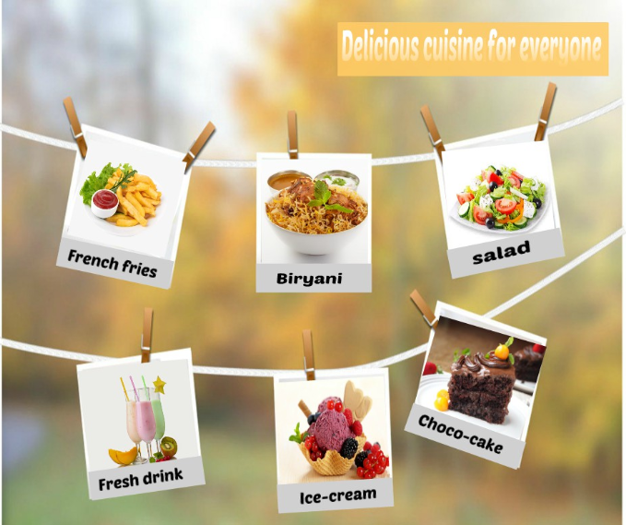

Industry:
This business belongs to Food Processing Industry (Preparing + Delivering). It will be a Kitchen-based business.

Current Financial Status:
This industry is growing really fast in Pakistan. Food & Beverages processing is the 2nd largest industry in Pakistan, after textiles which accounts for 27% of the value-added production and 16% of employment in the manufacturing sector.
Pakistan is switching to online, everything is on our fingertips. More and more people are interested in ordering online food. Online food-ordering business estimates at Rs.15 billion a year according to the industry sources.

Aim & Objective:
- To provide customers with the best quality food and fast delivery service to create trusted relationship with the customer and to ensure high level of customer satisfaction.
- To expand the services to all over Pakistan
- To generate maximum financial return
- Continuous improvement

Mission Statement:
“To provide high quality food and fast delivery service to the customer, to improve and expand in the business by maintaining trustable and long-term relationship with the customer and as well as with the employees”

Size of initial setup:
- As it will be a home-based business. So it will just require a clean and hygienic kitchen.
- It will start delivering food in some areas of Rawalpindi.
- Starting with a team of 5 members.
- This business will start taking maximum orders for 30 people a day, from 11 am to 5 pm.

Finance Required:
- For preparing meal for 30 people (chicken, vegetables dishes, fast food dishes), and to deliver food to customer’s doorstep, it will require finance of minimum Rs. 40,000 to Rs. 45,000.
- On a higher level, it will require a maximum finance of Rs. 1 lac to 5 lacs
- This finance will be used mostly on
  - Ingredients, delivering food and salaries of employees.
  - Small business software/ App (for finance related activities)
  - Website development
Income Statement
Revenue |  | 2021 | 2022 | 2023 | 2024
Total sales |  | PKR 100,000 | 200,000 | 3,000,00 | 5,000,00
Total cost |  | 20,000 | 40,000 | 50,000 | 60,000
Gross Profit |  | 80,000 | 160,000 | 250,000 | 440,000
Total Revenue |  | 80,000 | 160,000 | 250,000 | 440,000

HR Policy:
- It is important to take care of hygiene and cleanliness while preparing food, so first responsibility will be to take of the purity of food provided to the customer.
- Hiring will be done without any discrimination and favoritism. All the team members involved in preparation and delivery of the food should specialized knowledge and experience.
- Chefs/cooks who will be hired for this work should first sent their details for authenticity, and pictures of their kitchen set up to ensure cleanliness and hygiene.
- A separate department will be made who will check the hygiene level of kitchen set ups and for compilation of all the information regarding employees.
- Training will be given to all employees once a week
- Communication medium will be made easier for the employees as well as for the customer for better understanding and relationships.
- Timely salaries and benefits will be given to employees
- Feedback mechanism will be made for the employees as well as for the customers, so that business can improve itself and meet the customers need and requirement.
- Reward will be given after every 3 months to those employees who performed best during this tenure.

Worker Motivation Techniques:
- Give them Authority
  - Employees will be given responsibilities according to their skills and abilities. Certain tasks will be assigned. And then they will be given all the authority to complete this task according to their own methods and strategies but they should use fair means to complete a task. This will built confidence in them and they will perform at their best.

- Recognize their Achievements:
  - The employees’ performance will be tracked throughout. And after every 3 months, the employee who performed best during this tenure, will get a reward for his performance. This will motivate him and as well as other employees to work hard.

Leadership style:
- Consultative leadership style will be used, because it takes the input from the employers for problem solving. But the final decision still rests with the top management. It will make the employees feel important and will be encouraged to work hard.

Target market
- Target market will be local, middle class including students and office workers etc. because they are the ones who are most interested to order online food and as this business is providing home-made hygienic food, so it will convenient for them to order and get their food in minutes.

Plan to Sell
- This business will be online as more and more people are using online services now a days. It is a going trend and this business will take advantage of it.

- Online Website:
  - Online website will be developed for this purpose as it will be easier for customers to order food.
  - This website will have menus for the customers, they can choose from any menu according to their choice and budget.
  - This website will have a proper delivery system and the payment details mentioned for the convenience of customers.
  - The customers will be able to order food by entering their email address.
  - The business will make sure to maintain privacy of their customers and employees.
  - This website will also have an opportunity for job seekers to apply for any, job including Cook, delivery boy, accountant, manager etc.
  - Job requirements will be mentioned on this website for every type of job. Job seekers will apply for the specific job and will be approached by the team if they meet certain qualifications.
  - Feedback section will be made separately for the customers as well as for the employees so that they can share their views on the service. They can also share what difficulties they are facing in the provided service and what ways can be used to improve the service. This feedback will be responded and all the suggestions will be taken into consideration to build strong, long-term and trustworthy relationship with the employees as well as with the customers.

How to manage inventory;
- As this is a home-based business so all the cooks will be preparing food from their home. But they will hired after the Kitchen hygiene test which will conducted by the management of the business to ensure quality of the service.
- Finance related matters will be managed by the owner in start, but later there will be a proper team who will manage all the finance related activities through a proper system e.g. an app/software where all the financial dealings will be recorded.

Methods of promotion:
- Social Media:
  - Business will be promoted on different social media websites including Facebook, Instagram etc.
  - Write blogs on LinkedIn

- Customer Referral Program:
  - Offering customer discounts on first order and free gift with first order will create a positive word of mouth. (only for first 100 orders)
  - Every existing customer will get a code. If a new customer comes in with the reference of the existing customer (by showing code number), he will get 50% on his first order(1 time offer)

- Pamphlets:
  - Pamphlets will be distributed among people, on which all the dishes and their prices will be mentioned along with Number for ordering and time in which the food will be delivered to them.
  - These will be made colorful to attract maximum number of customers
  - Conditions of customer referral programs will be mentioned on these pamphlets.

Competitive analysis
Some of the big competitors of this business are Cheetaytiffin.pk, homechef.pk and Lunch.pk
- It is true that online business in Home-made food is already there working on a very fast rate. But the network of these business is not very large. Most of the home-made food businesses only offer in their nearer areas.
- But this business is offering several incentives for the employees as well as for the customers.
- It is giving high quality food to its customers but also it is creating job opportunities for those who are unemployed.
- It is offering special trainings for the employees working with them.
- All these offers are not often found in other online food ordering websites.

Financial income statement
Income Statement
Revenue |  | 2021 | 2022 | 2023 | 2024
Total sales |  | PKR 50,000 | 800,000 | 15,000,00 | 20,000,00
Total cost |  | 100,000 | 300,000 | 500,000 | 700,000
Gross Profit |  | 400,000 | 500,000 | 10,000,00 | 13,000,00
Total Revenue |  | 400,000 | 500,000 | 10,000,00 | 13,000,00

Conclusion
As online businesses are increasing day by day and also most of the people now a days are interested in ordering food online, this is great opportunity to start a business in this. The industry is growing fast and also gaining high financial returns. Home cooked food is hygienic and promoting this business will create a new trend of preferring home cooked food on local unhygienic food which not healthy for the health. To make this business successful, it is very important to make good, strong and trustable relationships with the employees and with the customers, which can only be possible by proving them with best high quality services and maintaining commitment. Taking the first step to any goal with an honest and sincere heart will surely take people to the achievement of their goals. If this business plan is implemented properly and with hard-work, compassion and commitment, then it can create a history in online businesses.

References
Munir, S., & Ali, S. H. (2019). Assessing Awareness, Attitude, and Practice of Food Safety Among the Population of Quetta, Pakistan. Advances in Bioscience and Bioengineering, 7(3), 43.
Sikandar, M. D. I., & Ahmed, Q. M. (2019). Impact of Social Media Marketing on Brand Love: Promoting Loyalty in the Restaurant Landscape of Pakistan. Online Journal of Communication and Media Technologies, 9(4), e201927.

